SOCIETY FOR CARDIOVASCULAR PATHOLOGY, INC.
2024 Annual Dues
January 1, 2024- December 31, 2024
Society dues may be paid by check, PayPal or Venmo. Just log onto SCVP Web site (http://scvp.net), click “Join/Renew.” At the bottom of the page is our PayPal set up. This is a secure system where you can enter your credit card information and pay your SCVP dues online. Or use the QR code below and your smart phone Venmo App, if you use Venmo.

If you choose to pay by check, please enter your name, any address changes and your e-mail address on this form and return this form with your remittance:

Full Membership Fee
U.S. and Canadian mailing address $200.00 ____________________

Mailing Address outside U.S. and Canada $200.00 ____________________

Trainee Membership Fee
U.S. & Canadian mailing address $65.00 ____________________

Emeritus Members
U.S. & Canadian mailing address $113.00 ____________________

Mailing address outside U.S. and Canada $113.00 ____________________

Contribution to Educational Endowment Fund ____________________

Total Payment Enclosed ______________________
(U.S. Currency draws on a U.S. book0
Please make your check payable to: Society for Cardiovascular Pathology, Inc.,
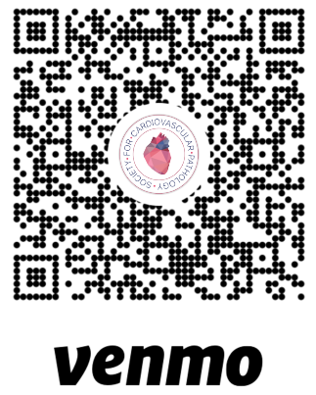
Please be aware that members can contribute extra funds levels as bronze ($50), silver ($100), and gold ($200) for additional SCVP swag (silver and gold), a free membership for a fellow (gold), and recognition in the newsletter.
Society for Cardiovascular Pathology, Inc.
c/o Dr. Silvio Litovsky, SCVP Treasurer
UAB Pathology, PD6A 175
1960 6th Avenue South
Birmingham, AL 35294 USA
E-mail: slitovsky@uabmc.edu

